name:________________________
Period:______________________

screwdrivers and pliers
Directions — Answer the following questions by writing all responses on this sheet.

1. Match the tool with its name by placing the appropriate number in the blank. All the illustrations will not be used.

____ A. Adjustable-
joint pliers

____ B. Locking
pliers

____ C. Long-nose
pliers

____ D. Nut driver

____ E. Phillips
screwdriver

____ F. Slip-joint
pliers

____ G. Snap-ring
pliers

____ H. Standard
screwdriver

1.
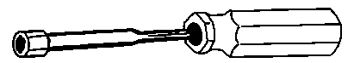

2.
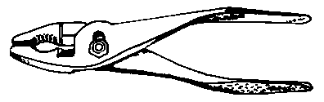

3.
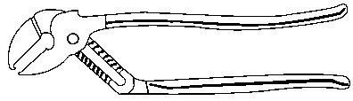

4.
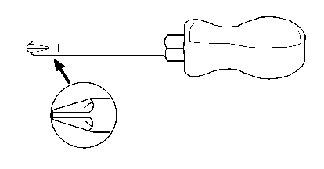
5.
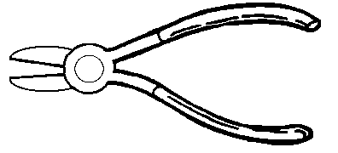

6.
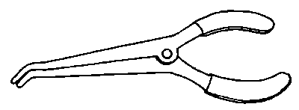

7.
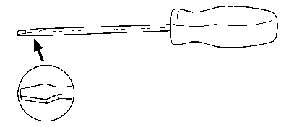

8.
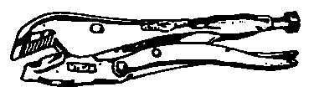

9.
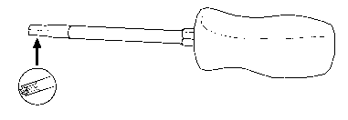

10.
