,Name:___________________________
Period:_________________________

hammers, punches, and chisels
Directions — Answer the following questions by writing all responses on this sheet.

1. Match the tool with its name by placing the appropriate number in the blank. All the illustrations will not be used.

____ A. Ball peen
hammer

____ B. Diamond-
point chisel

____ C. Plastic-tip
hammer

____ D. Rubber
mallet

____ E. Sledge-
hammer

____ F. Standard
chisel

____ G. Starting
punch

1.

2.

3. 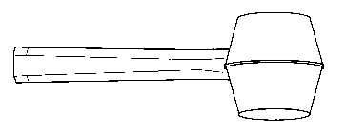

4.

5.

6. 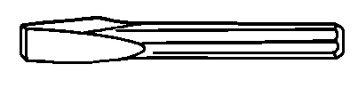

7.

8.

9.

