Name:_____________________
Period:___________________
wrenches
Directions — Answer the following questions by writing all responses on this sheet.

1. Match the tool with its name by placing the appropriate number in the blank. All the illustrations will not be used.

____ A. Box wrench

____ B. Breaker bar

____ C. Pipe wrench

____ D. Ratchet

____ E. Swivel socket

____ F. Torque wrench

____ G. Tubing wrench

1.

2.

3. 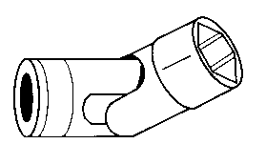

4. 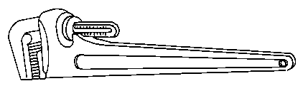

5.

6.

7.

8. 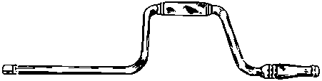

9. 