Name:_____________________
Period:___________________

basic hand tools TEST
Section A — Match the tool with its name by placing the appropriate letter in the blank. All the illustrations will not be used.

_____ 1. Ball peen hammer

_____ 2. Breaker bar

_____ 3. Center punch

_____ 4. Cold chisel

_____ 5. Combination-end
wrench

_____ 6. Locking pliers

_____ 7. Open-end wrench

_____ 8. Phillips
screwdriver

_____ 9. Pipe wrench

_____ 10. Plastic-tip
hammer

_____ 11. Ratchet

_____ 12. Snap-ring pliers

_____ 13. Standard
screwdriver

_____ 14. Torque wrench
A. 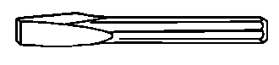

B.

C. 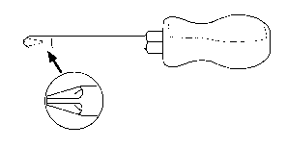

D. 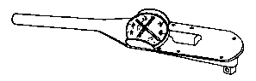

E.

AA.

AB. 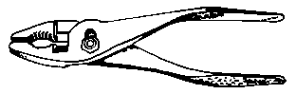

AC.
AD. 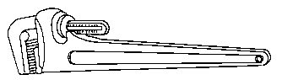

AE.

BA.

BB. 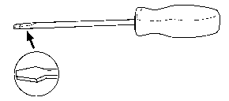

BC. 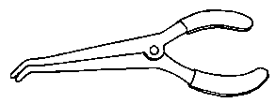

BD.

BE.

CA.

Section B — Select the best answer from the five choices listed.

_____ 15. The unit of measurement used for metric wrench sizes is

A. centimeters.
B. millimeters.
C. meters.
D. inches.
E. fractions of an inch.

_____ 16. A type of wrench commonly used to turn nuts and bolts that have already been loosened is the

A. open end.
B. box.
C. Allen.
D. flare nut.
E. torx.

_____ 17. A type of wrench that completely encircles the nut or bolt is the

A. open end.
B. box.
C. Allen.
D. flare nut.
E. adjustable.

_____ 18. A type of wrench that is used to loosen steel line fittings is the

A. torx.
B. box.
C. adjustable.
D. tubing.
E. Allen.

_____ 19. A type of wrench that has a screw that allows the jaw to adjust to different sizes is the

A. open end.
B. box.
C. combination.
D. flare nut.
E. adjustable.

_____ 20. What type of socket is used to turn nuts when a long portion of the bolt or stud protrudes through the nut?

A. Shallow
B. Impact
C. Swivel
D. Deep well
E. None of the above

_____ 21. What type of wrench handle is required to measure the amount of twisting force that is being applied in tightening a bolt?

A. Torque
B. Ratchet
C. Speed
D. Breaker bar
E. T-handle

_____ 22. Which screwdriver is designed to be used as a chisel?

A. Standard
B. Phillips
C. Torx
D. All of the above
E. None of the above

_____ 23. Which pliers have a knob to clamp the handles in place?

A. Slip joint
B. Locking
C. Adjustable joint
D. Long nose
E. Diagonal cutting

_____ 24. Which pliers are used for cutting wire and tape?

A. Slip joint
B. Locking
C. Adjustable joint
D. Long nose
E. Diagonal cutting

_____ 25. The most common hammer used for driving punches and chisels is the

A. sledgehammer.
B. plastic tip.
C. ball peen.
D. rubber mallet.
E. soft faced.

_____ 26. Which hammer is best when a great deal of driving power is required?

A. Sledgehammer
B. Plastic tip
C. Ball peen
D. Rubber mallet
E. Soft faced

_____ 27. Which punch is used for marking drill holes prior to drilling?

A. Starting
B. Pin
C. Center
D. Brass
E. None of the above

Section C — Read the following statements made by Technicians A and B. Indicate which is correct by selecting from the four choices listed.

_____ 28. Technician A says the size of USCS wrenches is given in fractions of an inch.

Technician B says it is okay to use a USCS wrench on a metric fastener if it is close in size.

Who is correct? A. A only
B. B only
C. Both are correct.
D. Neither is correct.

_____ 29. Technician A says there is less chance of damaging a bolt when using a box wrench.

Technician B says an adjustable wrench does not grip as solidly as a box wrench.

Who is correct? A. A only
B. B only
C. Both are correct.
D. Neither is correct.

_____ 30. Technician A says universal sockets are used when straight-on access to bolts is not possible.

Technician B says impact sockets are not as strong as standard sockets.

Who is correct? A. A only
B. B only
C. Both are correct.
D. Neither is correct.

_____ 31. Technician A says a ratchet handle can turn both counterclockwise and clockwise by flipping a small switch on the tool.

Technician B says the sockets used on socket wrenches are adjustable.

Who is correct? A. A only
B. B only
C. Both are correct.
D. Neither is correct.

_____ 32. Technician A says a T-handle is used when extra leverage is required.

Technician B says a torque wrench measures the twisting force that is being applied in tightening a bolt.

Who is correct? A. A only
B. B only
C. Both are correct.
D. Neither is correct.

_____ 33. Technician A says a Pozidriv screwdriver and Phillips screwdriver are interchangeable.

Technician B says a standard screwdriver also is designed to be used for a pry bar or gasket scraper.

Who is correct? A. A only
B. B only
C. Both are correct.
D. Neither is correct.

_____ 34. Technician A says nut drivers are useful for quickly removing small nuts and bolts on vehicles.

Technician B says the socket at the tip of nut drivers is not removable.

Who is correct? A. A only
B. B only
C. Both are correct.
D. Neither is correct.

_____ 35. Technician A says locking pliers are required for spreading or compressing springy snap rings.

Technician B says diagonal-cutting pliers will be damaged if used to cut spring steel.

Who is correct? A. A only
B. B only
C. Both are correct.
D. Neither is correct.

_____ 36. Technician A says brass hammers can be used on iron and steel components because they do minimal damage.

Technician B says a plastic-tip hammer is the most common hammer used to drive punches and chisels.

Who is correct? A. A only
B. B only
C. Both are correct.
D. Neither is correct.

_____ 37. Technician A says a hammer with a handle that is a little loose is still safe to use.

Technician B says a flat-surfaced hammer should only be struck at an angle to the surface being struck.

Who is correct? A. A only
B. B only
C. Both are correct.
D. Neither is correct.

_____ 38. Technician A says punches are used to cut or chip metal.

Technician B says a taper punch is designed to drive out rivets after the rivet head has been removed.

Who is correct? A. A only
B. B only
C. Both are correct.
D. Neither is correct.

_____ 39. Technician A says a punch should be struck with a heavy hammer blow.

Technician B says heavy gloves and safety glasses should be worn when working with punches and chisels.

Who is correct? A. A only
B. B only
C. Both are correct.
D. Neither is correct.

_____ 40. Technician A says, if a punch or chisel has a mushroomed head, the mushroomed metal may fly off the tool.

Technician B says, if a punch or chisel has a mushroomed head, the hammer slips off the head more easily.

Who is correct? A. A only
B. B only
C. Both are correct.
D. Neither is correct.

